ESTIMATING PORTFOLIO VALUE AT RISK
A Comparative Application of the Historical Simulation and
Parametric Methods to an Indian Large-Cap Equity Portfolio
Internship Project Report — Market Risk Analytics
Prepared by
Shaashwat Dhar
2022A4PS1521H
June 2026
Asset universe: Nestlé India · Pidilite Industries · Divi’s Laboratories · Bosch · UltraTech Cement

Abstract
This report estimates the one-day and ten-day Value at Risk (VaR) of an equally weighted portfolio of five large-capitalisation Indian equities — Nestlé India, Pidilite Industries, Divi’s Laboratories, Bosch and UltraTech Cement — each allocated Rs 100,000 for a total portfolio value of Rs 500,000. Using approximately one year of daily closing prices (June 2025 to June 2026), VaR is computed at the 95% and 99% confidence levels using two industry-standard approaches: the Historical Simulation method and the Parametric (Variance–Covariance, or Delta-Normal) method. At the 95% level the two methods agree closely (Rs 7,926 versus Rs 8,014 for the one-day horizon), but at the 99% level they diverge materially (Rs 15,824 historical versus Rs 11,395 parametric), illustrating the parametric model’s tendency to understate losses in the presence of fat tails. A standalone-versus-diversified comparison reveals a diversification benefit of approximately Rs 3,996, equal to 33.3% of the summed individual risks, confirming the loss-reducing effect of imperfect correlation across holdings. The findings are interpreted in the light of the established strengths and limitations of each method, and the report concludes with recommendations for extending the analysis to Expected Shortfall and longer estimation windows.
Table of Contents
Abstract 2
1. Introduction 4
2. Literature Review 4
3. Methodology 5
3.1 Data and Portfolio Construction 5
3.2 Return Computation 6
3.3 Method 1 — Historical Simulation 6
3.4 Method 2 — Parametric (Variance–Covariance) 6
3.5 Holding-Period Scaling and Standalone VaR 6
4. Results and Discussion 7
4.1 Portfolio Value Path 7
4.2 Distribution of Returns and Normality 7
4.3 Portfolio VaR Estimates 8
4.4 Covariance Structure 8
4.5 Standalone Risk and the Diversification Benefit 9
4.6 Time Variation of Risk 10
5. Conclusion 10
References 11

1. Introduction
Risk is intrinsic to participation in financial markets. Because asset prices move unpredictably, any investor or institution holding a portfolio is exposed to the possibility of loss, and prudent management of that exposure requires it to be measured before it can be controlled. Over the past three decades, Value at Risk has become the single most widely used summary measure of market risk, valued precisely because it expresses a complex, multi-asset risk profile as one monetary figure that managers, regulators and clients can readily interpret.
Formally, the Value at Risk of a portfolio at a confidence level of (1 − α) over a holding period h is the loss that is not expected to be exceeded with probability (1 − α) over that period. Equivalently, it is the α-quantile of the distribution of portfolio losses. For example, a one-day 95% VaR of Rs 7,926 carries the interpretation that, under normal market conditions, there is only a 5% chance of the portfolio losing more than Rs 7,926 over a single trading day. VaR is therefore a statement about a threshold of loss, not about the average loss, and not about the worst conceivable loss.
This study applies the concept to a concrete, equally weighted portfolio of five large-capitalisation Indian equities drawn from distinct sectors. The objectives are fourfold: (i) to estimate portfolio VaR using two of the three canonical methods — Historical Simulation and the Parametric Variance–Covariance approach; (ii) to compare the two methods at the 95% and 99% confidence levels across one-day and ten-day horizons; (iii) to quantify the diversification benefit by contrasting the portfolio VaR with the sum of the individual standalone VaRs; and (iv) to visualise the portfolio’s risk profile, including its return distribution and the time variation of its risk. The analysis is based on approximately 247 daily closing prices per stock (yielding 246 daily log-returns) covering one year of trading from June 2025 to June 2026.
The remainder of the report is organised as follows. Section 2 reviews the literature on VaR and its principal estimation methods. Section 3 sets out the data, the portfolio construction and the methodology for each VaR approach. Section 4 presents and discusses the empirical results, supported by figures generated from the underlying workbook. Section 5 concludes and outlines limitations and directions for further work.

2. Literature Review
Value at Risk rose to prominence in the mid-1990s, when J.P. Morgan released its RiskMetrics methodology and the supporting datasets that allowed institutions to compute market risk on a common, transparent basis [1]. Its adoption was accelerated decisively by regulation: the 1996 Market Risk Amendment to the Basel Capital Accord permitted banks to use internal VaR models to determine market-risk capital charges, embedding the measure at the centre of prudential supervision and cementing its status as the industry standard [2].
The literature distinguishes three canonical approaches to estimating VaR. The Historical Simulation method is non-parametric: it re-prices the current portfolio using the empirical distribution of past returns and reads VaR directly off the realised loss distribution, thereby making no assumption about the shape of that distribution. The Parametric, or Variance–Covariance, method — also called the Delta-Normal method — assumes that returns are normally distributed and derives VaR analytically from the portfolio mean and standard deviation, the latter obtained from the variance–covariance matrix of the constituent assets [3]. The Monte Carlo method simulates a large number of hypothetical return paths from an assumed stochastic model and computes VaR from the simulated loss distribution. Each approach embodies a trade-off: the parametric method is fast and analytically tractable but rests on the normality assumption; historical simulation is assumption-light but is bounded by the observed sample and presumes that the past is representative of the future; Monte Carlo is the most flexible but is computationally intensive and only as reliable as the model it assumes [4][5].
The principal criticisms of VaR concern both the normality assumption and the measure itself. Empirical studies of asset returns, beginning with Mandelbrot, have long documented heavy tails and volatility clustering — properties that the normal distribution cannot reproduce and that cause parametric VaR to understate the likelihood of extreme losses [6]. More fundamentally, Artzner, Delbaen, Eber and Heath showed that VaR is not a coherent risk measure, because it can violate sub-additivity: the VaR of a combined portfolio may, in principle, exceed the sum of the VaRs of its parts, contradicting the intuition that diversification should never increase risk [7]. VaR is also silent about the severity of losses beyond its threshold. These concerns motivated the development of Expected Shortfall (also known as Conditional VaR), which measures the average loss in the tail beyond the VaR cut-off and which the Basel Committee subsequently adopted in place of VaR for market-risk capital under the Fundamental Review of the Trading Book [8].
Finally, the conversion of risk from one horizon to another typically relies on the square-root-of-time rule, under which the h-day VaR is approximated as the one-day VaR scaled by √h. This rule is exact only when returns are independent and identically distributed with zero mean; in the presence of autocorrelation or volatility clustering it is an approximation, and one that is nonetheless retained here for comparability with standard practice.

3. Methodology

3.1 Data and Portfolio Construction
The portfolio comprises five large-capitalisation equities listed on the Indian exchanges, deliberately selected from different sectors — fast-moving consumer goods (Nestlé India), specialty chemicals and adhesives (Pidilite Industries), pharmaceuticals (Divi’s Laboratories), automotive components (Bosch) and cement (UltraTech Cement) — so that the holdings are not driven by a single common industry factor. Each stock is assigned an equal weight of 20%, corresponding to an allocation of Rs 100,000 and a total portfolio value of Rs 500,000. One year of daily closing prices (approximately 247 observations per stock, June 2025 to June 2026) forms the estimation sample. Table 1 summarises the portfolio composition using the latest available closing prices.
Asset | Weight | Allocated Value (Rs) | Latest Price (Rs) | Units Held
Nestlé India | 20% | 100,000 | 2,058.42 | 48.58
Pidilite Industries | 20% | 100,000 | 3,071.00 | 32.56
Divi’s Laboratories | 20% | 100,000 | 6,638.00 | 15.06
Bosch | 20% | 100,000 | 39,062.20 | 2.56
UltraTech Cement | 20% | 100,000 | 11,117.00 | 9.00
Total | 100% | 500,000 | — | —
Table 1. Portfolio composition and equal-weight allocation.

3.2 Return Computation
Daily returns are computed as continuously compounded (logarithmic) returns, which are time-additive and therefore well suited to multi-period risk scaling. For each asset, the return on day t is the natural logarithm of the ratio of successive closing prices:
r_{t} = ln( P_{i,t} / P_{i,t−1} )
The portfolio return on each day is the weighted average of the individual asset returns, and the corresponding mark-to-market profit or loss (P&L) is obtained by multiplying the portfolio return by the portfolio value V:
R_{p,t} = Σ w_{i} · r_{i,t} and P&L_{t} = V · R_{p,t}
Applying this to the sample yields a portfolio with a mean daily return of 0.0296% and a daily standard deviation of 0.9924% over the year.

3.3 Method 1 — Historical Simulation
The Historical Simulation method treats the realised series of daily portfolio P&L as the empirical distribution of possible outcomes and reads VaR directly from it, without assuming any particular distributional form. The VaR at confidence level (1 − α) is the negative of the α-quantile (percentile) of the P&L series:
VaR_{HS,α} = − Percentile_{α} ( P&L series )
In the workbook this is implemented with the PERCENTILE.EXC function evaluated at 0.05 for the 95% level and 0.01 for the 99% level. Because it uses the actual return history, the method captures whatever skewness and fat-tailed behaviour are present in the data, but it can only reflect losses of a size that has already occurred within the sample window.

3.4 Method 2 — Parametric (Variance–Covariance)
The Parametric method assumes that portfolio returns follow a normal distribution with mean μ_{p} and standard deviation σ_{p}. VaR is then obtained analytically from the relevant quantile of the normal distribution. Reported as a positive loss, the VaR at confidence level (1 − α) is:
VaR_{param,α} = ( z_{α} · σ_{p} − μ_{p} ) · V
The portfolio standard deviation is computed from the full variance–covariance structure of the five assets rather than from individual volatilities alone, so that the correlations between holdings are properly accounted for. In matrix form, with w the vector of portfolio weights and Σ the 5×5 variance–covariance matrix of asset returns:
σ_{p} = √( w′ Σ w )
This expression is evaluated in Excel using nested MMULT matrix multiplication, giving a portfolio daily variance of 9.848×10⁻⁵ and hence a portfolio daily standard deviation of 0.9924%. The critical z-scores are obtained from the NORM.S.INV function: 1.6449 at the 95% level and 2.3263 at the 99% level.

3.5 Holding-Period Scaling and Standalone VaR
One-day estimates are converted to the ten-day horizon using the square-root-of-time rule, VaR_{h} = VaR₁ × √h, so that the ten-day figures equal the one-day figures multiplied by √10 ≈ 3.162. To quantify the diversification benefit, a standalone VaR is also computed for each stock, treating its Rs 100,000 allocation as if it were held in isolation. The diversification benefit is then the difference between the sum of the five standalone VaRs and the VaR of the diversified portfolio. All calculations were performed in Microsoft Excel using the PERCENTILE.EXC, STDEV.S, NORM.S.INV and MMULT functions.
Parameter | Value
Portfolio value | Rs 500,000
Confidence levels (one-tailed) | 95% and 99%
Holding periods | 1 day and 10 days
z-score @ 95% / 99% | 1.6449 / 2.3263
Daily return observations | 246 (one year)
Table 2. Key assumptions and parameters.

4. Results and Discussion

4.1 Portfolio Value Path
Figure 1 traces the simulated value of the Rs 500,000 portfolio over the sample period against its initial baseline. The portfolio fluctuated broadly between about Rs 455,000 and Rs 542,000, spending most of the year above the baseline but suffering a pronounced drawdown that carried it well below Rs 500,000 during an early-2026 stress episode. This single visible stress window is important context for the VaR estimates that follow, because it is the source of the largest realised daily losses in the sample.
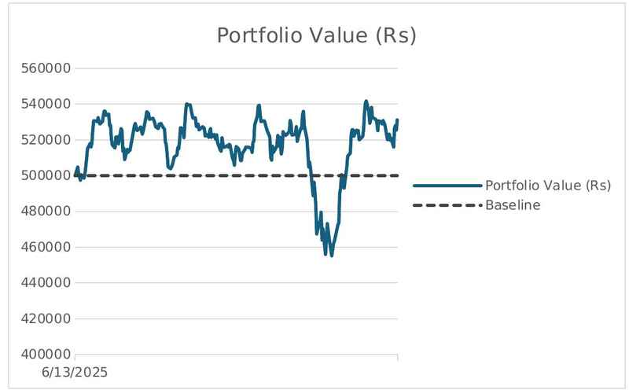
Figure 1. Simulated portfolio value over the sample period (baseline = Rs 500,000).

4.2 Distribution of Returns and Normality
Figure 2 overlays the histogram of daily portfolio returns on a fitted normal curve. The empirical distribution is visibly more peaked around zero than the normal and exhibits a fatter left tail, with several observations clustered in the −3% to −2% region that the normal density assigns negligible probability. This leptokurtosis is the practical reason the two VaR methods agree at moderate confidence but part company in the extreme tail, as the next subsection shows.
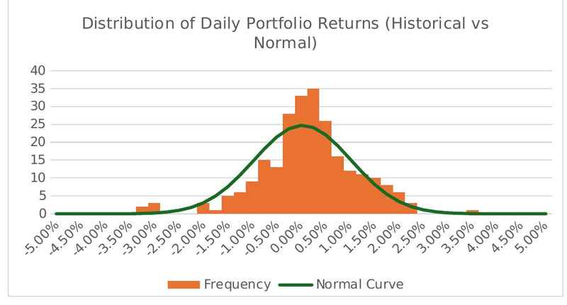
Figure 2. Distribution of daily portfolio returns (historical) versus the fitted normal curve.

4.3 Portfolio VaR Estimates
Table 3 reports the headline portfolio VaR figures from both methods, at both confidence levels and both horizons. The two methods produce almost identical estimates at the 95% level — Rs 7,926 (historical) against Rs 8,014 (parametric) for one day — because near the 5th percentile the empirical and normal quantiles of this return series are very close. At the 99% level, however, they diverge sharply: the historical estimate of Rs 15,824 exceeds the parametric estimate of Rs 11,395 by roughly 28%. This gap is a direct consequence of the fat left tail seen in Figure 2; the normal distribution underlying the parametric method simply does not place enough probability in the extreme tail, and so understates the loss that the historical record actually contains.
Method and confidence | 1-day VaR (Rs) | 10-day VaR (Rs)
Historical Simulation — 95% | 7,926 | 25,064
Historical Simulation — 99% | 15,824 | 50,039
Parametric — 95% | 8,014 | 25,341
Parametric — 99% | 11,395 | 36,035
Table 3. Diversified portfolio VaR by method, confidence level and horizon.
Expressed against the Rs 500,000 portfolio, the one-day 95% figures represent a potential loss of about 1.6% of value, rising to roughly 2.3–3.2% at the 99% level depending on method. The ten-day figures, obtained by the √10 scaling, indicate that under the historical method a 99% loss of about Rs 50,000 — ten percent of the portfolio — is conceivable over a two-week horizon.

4.4 Covariance Structure
The parametric estimate depends on the full variance–covariance matrix of the five assets, shown as a heat map in Figure 3. The leading diagonal, which carries the individual asset variances, holds the largest values, while every off-diagonal covariance is positive but materially smaller. The conditional shading flags the relative magnitudes, with the largest entries tinted green and the smallest red. Because the assets are only partially correlated rather than moving in lockstep, the portfolio variance is much smaller than a simple weighting of individual variances would suggest — which is precisely the mechanism behind the diversification benefit quantified next.
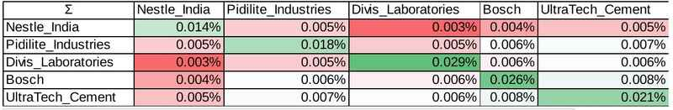
Figure 3. Variance–covariance matrix of the five assets (conditional formatting: green = highest, red = lowest).

4.5 Standalone Risk and the Diversification Benefit
Table 4 presents the standalone VaR of each holding alongside its daily volatility. Bosch is the riskiest single name, with a daily standard deviation of about 1.84% and the largest standalone VaR, while Pidilite Industries is the least volatile at roughly 1.30%. Summing the five standalone parametric VaRs at the 95% level gives Rs 12,009, whereas the diversified portfolio VaR is only Rs 8,014.
Asset | Daily Std Dev | Hist 95% | Hist 99% | Param 95% | Param 99%
Nestlé India | 1.32% | 1,901 | 3,772 | 2,178 | 3,080
Pidilite Industries | 1.30% | 2,074 | 3,530 | 2,135 | 3,020
Divi’s Laboratories | 1.40% | 2,286 | 3,608 | 2,302 | 3,255
Bosch | 1.84% | 2,621 | 5,538 | 3,026 | 4,279
UltraTech Cement | 1.44% | 2,205 | 4,812 | 2,369 | 3,350
Sum of standalone | — | 11,088 | 21,261 | 12,009 | 16,985
Table 4. Standalone (undiversified) one-day VaR by asset (Rs).
Figure 4 contrasts the standalone risks with the diversified portfolio. The first five bars are the individual standalone VaRs; the final pair shows that pooling the holdings reduces risk well below their sum. The diversification benefit — the difference between the summed standalone parametric VaR (Rs 12,009) and the diversified portfolio VaR (Rs 8,014) — amounts to Rs 3,996, or 33.3% of the undiversified total. In other words, holding the five stocks together rather than separately removes roughly one-third of the measured risk. Notably, the portfolio VaR is smaller than the sum of its parts, so sub-additivity holds in this instance, even though it is not guaranteed by VaR in general.
Diversification analysis (Parametric, 95%) | Value
Sum of standalone parametric VaR | Rs 12,009
Diversified portfolio parametric VaR | Rs 8,014
Diversification benefit (Rs) | Rs 3,996
Diversification benefit (%) | 33.3%
Table 5. Diversification benefit at the 95% confidence level.
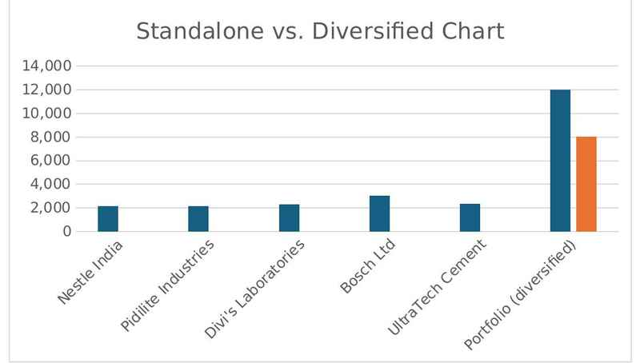
Figure 4. Standalone VaR by asset versus the diversified portfolio VaR (Rs).

4.6 Time Variation of Risk
VaR is not a static quantity. Figure 5 plots a rolling 30-day VaR at both confidence levels across the year. Risk was relatively contained for much of the period but rose sharply during the early-2026 stress window — the same episode visible as the drawdown in Figure 1 — with the rolling 95% and 99% measures climbing towards Rs 16,000 before subsiding as conditions normalised. This time variation underscores an important caveat: a single full-sample VaR estimate averages over calm and turbulent periods alike, and ongoing monitoring of a rolling estimate gives a far more honest picture of how exposure evolves.
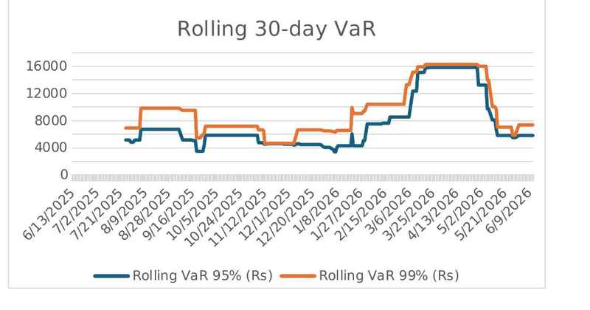
Figure 5. Rolling 30-day VaR at the 95% and 99% confidence levels (Rs).

5. Conclusion
This report estimated the Value at Risk of an equally weighted, cross-sector portfolio of five large-capitalisation Indian equities using both the Historical Simulation and the Parametric Variance–Covariance methods. The two approaches agree closely at the 95% confidence level but diverge substantially at the 99% level, where the historical estimate is roughly 28% larger than the parametric one. The explanation lies in the data: the portfolio’s return distribution is fatter-tailed than the normal distribution assumed by the parametric method, so the parametric model understates the probability — and therefore the magnitude — of extreme losses. The practical implication is that the choice of method matters most exactly where it matters most to a risk manager, namely deep in the loss tail.
The analysis also demonstrated a clear diversification benefit. Combining the five holdings reduced the 95% parametric VaR by about Rs 3,996, or one-third, relative to holding them in isolation, a direct result of the imperfect correlation evident in the variance–covariance matrix. The rolling-window analysis further showed that risk is far from constant, rising markedly during a stress episode before receding — a reminder that any single VaR number is a snapshot rather than a permanent characteristic of the portfolio.
Several limitations should temper the interpretation of these results. The estimation window spans only one year, so the historical method can reflect only the losses contained in that relatively short sample. The parametric method’s normality assumption is, as shown, violated in the tail. The square-root-of-time scaling presumes serially independent returns. More fundamentally, VaR is silent about the size of losses beyond its threshold and, as a non-coherent measure, does not in general guarantee sub-additivity. The study also omits the Monte Carlo approach and does not perform formal backtesting of the estimates.
Future work could address these points by adopting Expected Shortfall (Conditional VaR) alongside VaR to capture tail severity, extending the estimation window and incorporating volatility models such as EWMA or GARCH to reflect changing volatility, adding a Monte Carlo engine for greater distributional flexibility, and validating the estimates through Kupiec and Christoffersen backtests. Together these extensions would build on the present framework to deliver a more complete and regulation-aligned picture of portfolio risk.

References
- J.P. Morgan / Reuters (1996). RiskMetrics — Technical Document, 4th edition. New York.
- Basel Committee on Banking Supervision (1996). Amendment to the Capital Accord to Incorporate Market Risks. Bank for International Settlements, Basel.
- Jorion, P. (2007). Value at Risk: The New Benchmark for Managing Financial Risk, 3rd edition. McGraw-Hill, New York.
- Linsmeier, T. J., & Pearson, N. D. (2000). Value at Risk. Financial Analysts Journal, 56(2), 47–67.
- Hull, J. C. (2018). Risk Management and Financial Institutions, 5th edition. Wiley, Hoboken, NJ.
- Mandelbrot, B. (1963). The Variation of Certain Speculative Prices. The Journal of Business, 36(4), 394–419.
- Artzner, P., Delbaen, F., Eber, J.-M., & Heath, D. (1999). Coherent Measures of Risk. Mathematical Finance, 9(3), 203–228.
- Basel Committee on Banking Supervision (2019). Minimum Capital Requirements for Market Risk (Fundamental Review of the Trading Book). Bank for International Settlements, Basel.

